In this assignment we are going to work with Reinforcement learning using the environment in Mountain Car and Roulette problems. Now let’s look up the way we are going to work on RL first.

RL(Q-Learning) approaches to solve a problem by taking some random action and overviewing the reward allocated on reaching the goal, it learns by reinforcing the action yielding positive rewards. It maintains a Q-table that keeps track of the action taken and whether the goal is reached or not and thus allotting the reward/penalty accordingly.

Let’s also overview how the reward system works and how the Q-table is updated. So, whenever the action taken by the agent accumulates to reach the goal then positive points (reward) is awarded and when the goal is not reached then negative points (penalty) is awarded. Another thing to note here is our choice of action to maintain the balance between exploration and exploitation of action. If Q-learning parameter (ϵ) allows exploration then we greedily choose a random action, else exploit the highest Q-table to decide the most favourable action to reach the goal. Now over to the Q-table updation, it is guided by the equation:
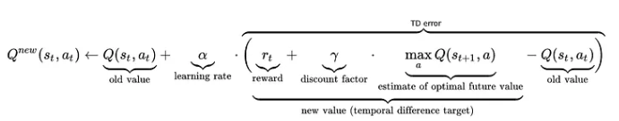

Also, given below is the python implementation:

Now let’s go through the MountainCar problem, the RL is going to use Q-Learning which defines a space of position, velocity and action taken. This helps the agent in deciding the future action and thus helps calculate the expected reward/penalty. The Q-state dimension is defined as: [position]*[velocity]*[action].

The first step of learning our agent is to discretize the position and velocity (since q-learning works on discrete space but actually position and velocity is continuous). The position and velocity space is divided into smaller discrete steps.

The agent learning the system, starts by selecting random action, evaluates the result and logs the reward/penaly to the Q-table. This step is repeatedly performed unless the agent can deterministically determine the next step of action to reach the goal.
Let’s now go through the code:
def create_bins(state_space, bins_per_feature=20):
bins = [np.linspace(low, high, bins_per_feature) for low, high in zip(state_space.low, state_space.high)]
return bins

def discretize_state(state, bins):
state_index = tuple(np.digitize(s, b) - 1 for s, b in zip(state, bins))
return state_index

def choose_action(Q, state, epsilon, n_actions):
if np.random.random() < epsilon:
return np.random.randint(n_actions)
else:
return np.argmax(Q[state])

def update_q(Q, state, action, reward, next_state, alpha, gamma):
Q[state][action] += alpha * (reward + gamma * np.max(Q[next_state]) - Q[state][action])
def q_learning(env_name, episodes=5000, alpha=0.1, gamma=0.99, epsilon=1.0, epsilon_decay=0.999, epsilon_min=0.05, bins_per_feature=20, render_interval=500):
env = gym.make(env_name)
bins = create_bins(env.observation_space, bins_per_feature)
n_actions = env.action_space.n

Q = np.zeros(tuple([bins_per_feature]*len(env.observation_space.low) + [n_actions]))
rewards = []

for episode in range(episodes):
state = discretize_state(env.reset()[0], bins)
done = False
total_reward = 0

while not done:
action = choose_action(Q, state, epsilon, n_actions)
next_state_cont, reward, done, truncated, _ = env.step(action)
next_state = discretize_state(next_state_cont, bins)

update_q(Q, state, action, reward, next_state, alpha, gamma)
state = next_state
total_reward += reward

rewards.append(total_reward)
epsilon = max(epsilon_min, epsilon * epsilon_decay)

if episode % render_interval == 0:
clear_output(wait=True)
print(f"Episode: {episode}, Reward: {total_reward}, Epsilon: {epsilon:.3f}")

env.close()
return Q, rewards
def test_mountain_car(Q, env_name='MountainCar-v0', tests=5, bins_per_feature=20, render_mode=None):
env = gym.make(env_name, render_mode=render_mode)
bins = create_bins(env.observation_space, bins_per_feature)
n_actions = env.action_space.n
goal_reached_count = 0
all_test_frames = []

print(f"\nRunning {tests} tests for the agent...")

for test in range(tests):
state = discretize_state(env.reset()[0], bins)
done = False
total_reward = 0
goal_reached_in_test = False
frames = []

while not done:
if render_mode is not None:
frame = env.render()
if frame is not None:
frames.append(frame)

action = np.argmax(Q[state])
next_state_cont, reward, done, truncated, _ = env.step(action)
next_state = discretize_state(next_state_cont, bins)

state = next_state
total_reward += reward

if next_state_cont[0] >= 0.5:
goal_reached_in_test = True
break

if goal_reached_in_test:
goal_reached_count += 1
print(f"Test {test + 1}: Goal reached!")
if render_mode is not None:
all_test_frames.append(frames)
else:
print(f"Test {test + 1}: Goal not reached.")

env.close()
print(f"\nGoal reached in {goal_reached_count}/{tests} tests.")

return all_test_frames, goal_reached_count

test_frames, goal_count = test_mountain_car(Q_mountain, render_mode='rgb_array')

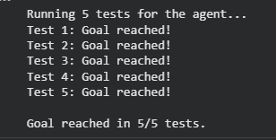
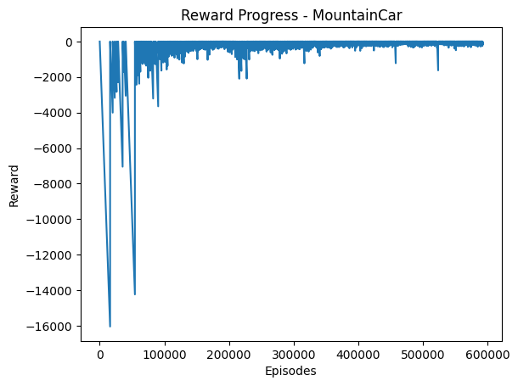
The final snapshot of the car reaching the goal is below:

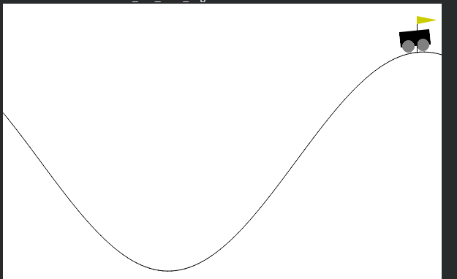
Now, let’s see the Roulette problem. The environment was not available in the gymnasium package hence needed to create a custom Roulette environment. The setup can be visualized as having a start balance, a target balance, bet value and discrete value to bet upon. At each round, the balances are reset and the values to bet upon are discretely divided. Then the roulette game starts where the agent puts its bet on the value and reaps its reward. This action is iteratively performed unless the agent goes broke or reaches the target mark or spin limit is reached. The action space is defined over the range of values available to bet on and the bet value available. Each action is thus a unique combination of (chosen bet number, chosen bet value). Also the reward shaping is one of the interesting parts. Whenever the iteration terminates, based on the net balance available, the reward is allotted. If the agent reaches the target balance, a positive reward is allotted. If the agent goes broke, a negative reward (penalty) is allotted. This shapes the agent’s decision making in the long run and thus helps reinforcing the positive action.

Let’s go through the code:
class RouletteEnv:
def __init__(self, start_balance=50, target_balance=100, max_steps=300):
self.start_balance = start_balance
self.target_balance = target_balance
self.max_steps = max_steps
self.bet_sizes = [1, 5, 10]
self.numbers = 37
self.action_space = self.numbers * len(self.bet_sizes)
self.reset()

def reset(self):
self.balance = self.start_balance
self.steps = 0
return self._discretize_balance(self.balance)

def _discretize_balance(self, balance):
return min(balance // 2, 150)

def step(self, action):
number_choice = action % self.numbers
bet_size = self.bet_sizes[action // self.numbers]

reward = 0
for _ in range(5): # average spins
spin = np.random.randint(0, 37)
if spin == number_choice:
reward += 35 * bet_size
else:
reward -= bet_size

self.balance += reward
self.steps += 1

done = self.balance <= 0 or self.balance >= self.target_balance or self.steps >= self.max_steps

shaped_reward = reward
if self.balance >= self.target_balance:
shaped_reward += 100
elif self.balance <= 0:
shaped_reward -= 50

next_state = self._discretize_balance(self.balance)
return next_state, shaped_reward, done
def q_learning(
episodes=8000,
alpha=0.15,
gamma=0.95,
epsilon=1.0,
epsilon_min=0.05,
epsilon_decay=0.9994
):
env = RouletteEnv()
state_space = 151
action_space = env.action_space
Q = np.zeros((state_space, action_space))
rewards_per_episode = []

for ep in range(episodes):
state = env.reset()
total_reward = 0

for _ in range(env.max_steps):
if random.random() < epsilon:
action = random.randint(0, action_space - 1)
else:
action = np.argmax(Q[state])

next_state, reward, done = env.step(action)
total_reward += reward

Q[state, action] += alpha * (reward + gamma * np.max(Q[next_state]) - Q[state, action])
state = next_state

if done:
break

epsilon = max(epsilon_min, epsilon * epsilon_decay)
rewards_per_episode.append(total_reward)

if (ep + 1) % 1000 == 0:
avg_reward = np.mean(rewards_per_episode[-1000:])
print(f"Episode {ep+1}/{episodes} | Avg Reward: {avg_reward:.2f}")

return Q, rewards_per_episode, env
def test_agent(Q, env, runs=10):
success_count = 0
for r in range(runs):
state = env.reset()
total_reward = 0
for _ in range(env.max_steps):
action = np.argmax(Q[state])
next_state, reward, done = env.step(action)
total_reward += reward
state = next_state
if done:
if env.balance >= env.target_balance:
success_count += 1
break
print(f"Test {r+1}: Final Balance = {env.balance}, Total Reward = {total_reward}")

print(f"\nGoal Reached in {success_count}/{runs} tests "
f"({(success_count / runs) * 100:.1f}% success rate)")

After testing the agent over 10 test cases below is the result:
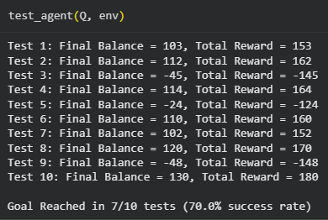

The reward plot available here:
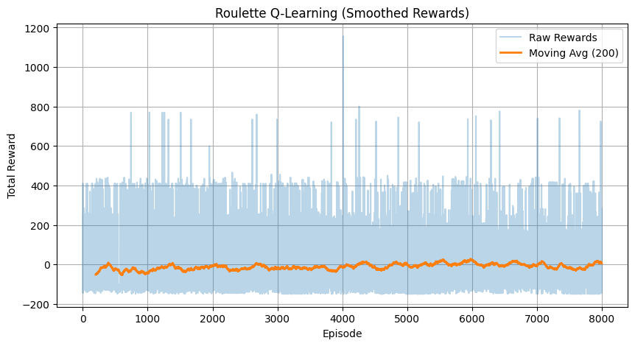
DQN over Mountain Car and Roulette problem.

Let’s go over the steps taken to create the DQN solution to the above problems. The DQN solution sought to replace the Q-table with a neural network which performs the mapping between the (state, action) → reward. Q-Learning needed the state values to be in discrete forms and that aroused some problems. Too coarse values, the agent learns poorly, too fine values, the Q-table explodes in size.

The target y in DQN is calculated as:
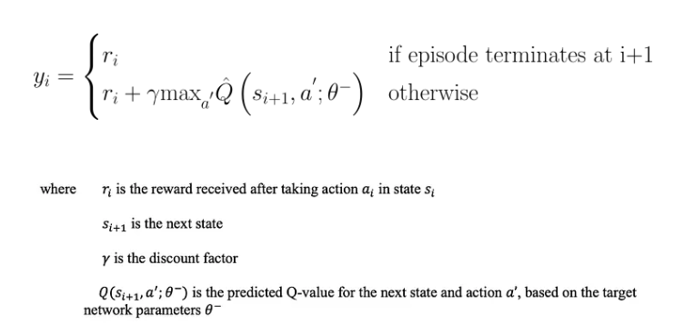

The loss function for the DQN is:
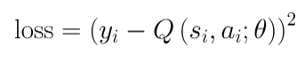

When the loss is calculated the gradient is updated in the network using the backpropagation algorithm. There is another provision called replay buffer which stores the action and reward. It also helps in training the model and breaks the sequential dependency on data such that the agent does not pick any action depending on sequential dependency and also encourages the agent to learn from the past experiences.

The approach to solve any problem remains largely similar to the Q-Learning step. The DQN teaches the agent through the following steps:

- Reset the environment.
- Greedily choose an action.
- Perform the action and log the action and reward to the replay buffer.
- Sample random batch from the replay buffer.
- Compute the Expected Q-value
- Compute the Current Q-value
- Calculate the loss
- Update the gradient
- Update the ϵ parameter affecting the choice of action.

The Mountain Car problem was also attempted to be solved using the DQN network.
device= torch.device("cuda" if torch.cuda.is_available() else "cpu")

class QNetwork(nn.Module):
def __init__(self, state_size, action_size, hidden_size=128):
super(QNetwork, self).__init__()
self.layers = nn.Sequential(
nn.Linear(state_size, hidden_size),
nn.ReLU(),
nn.Linear(hidden_size, hidden_size),
nn.ReLU(),
nn.Linear(hidden_size, action_size)
)

def forward(self, x):
return self.layers(x)

class ReplayBuffer:
def __init__(self, capacity=100000):
self.buffer = deque(maxlen=capacity)

def push(self, state, action, reward, next_state, done):
self.buffer.append((state, action, reward, next_state, done))

def sample(self, batch_size):
batch = random.sample(self.buffer, batch_size)
states, actions, rewards, next_states, dones = zip(*batch)
return (
torch.FloatTensor(states).to(device),
torch.LongTensor(actions).to(device),
torch.FloatTensor(rewards).to(device),
torch.FloatTensor(next_states).to(device),
torch.FloatTensor(dones).to(device),
)

def __len__(self):
return len(self.buffer)

def plot_rewards(reward_history, window=50):
"""Plot Reward vs Episode with optional moving average."""
plt.figure(figsize=(9, 5))
plt.plot(reward_history, color='blue', alpha=0.6, label="Reward per Episode")

if len(reward_history) >= window:
moving_avg = np.convolve(reward_history, np.ones(window)/window, mode='valid')
plt.plot(range(window - 1, len(reward_history)), moving_avg, color='red', label=f"{window}-ep Moving Avg")

plt.title("Reward vs Episodes (MountainCar DQN)")
plt.xlabel("Episode")
plt.ylabel("Reward")
plt.legend()
plt.grid(True)
plt.tight_layout()
plt.show()
def train_dqn(
env_name="MountainCar-v0",
episodes=1000,
batch_size=64,
gamma=0.99,
lr=1e-3,
epsilon_start=1.0,
epsilon_end=0.05,
epsilon_decay=0.995,
target_update_freq=10,
device= device
):
env = gym.make(env_name)
state_size = env.observation_space.shape[0]
action_size = env.action_space.n

policy_net = QNetwork(state_size, action_size).to(device)
target_net = QNetwork(state_size, action_size).to(device)
target_net.load_state_dict(policy_net.state_dict())
optimizer = optim.Adam(policy_net.parameters(), lr=lr)
buffer = ReplayBuffer()

epsilon = epsilon_start
all_rewards = []
goal_reached = False

for episode in range(1, episodes + 1):
state, _ = env.reset()
total_reward = 0
done = False

while not done:

if random.random() < epsilon:
action = env.action_space.sample()
else:
with torch.no_grad():
state_tensor = torch.FloatTensor(state).unsqueeze(0).to(device)
q_values = policy_net(state_tensor)
action = torch.argmax(q_values).item()

next_state, reward, terminated, truncated, _ = env.step(action)
done = terminated or truncated

position, velocity = next_state
shaped_reward = reward + (position + 0.5)

buffer.push(state, action, shaped_reward, next_state, done)
state = next_state
total_reward += reward

if len(buffer) >= batch_size:
states, actions, rewards, next_states, dones = buffer.sample(batch_size)
q_values = policy_net(states).gather(1, actions.unsqueeze(1)).squeeze(1)
with torch.no_grad():
next_q_values = target_net(next_states).max(1)[0]
target = rewards + gamma * next_q_values * (1 - dones)
loss = nn.MSELoss()(q_values, target)

optimizer.zero_grad()
loss.backward()
optimizer.step()

epsilon = max(epsilon_end, epsilon * epsilon_decay)
all_rewards.append(total_reward)

if episode % target_update_freq == 0:
target_net.load_state_dict(policy_net.state_dict())

if episode % 1000 == 0:
avg_reward = np.mean(all_rewards[-1000:])
print(f"Episode {episode}/{episodes} | Avg Reward (last 1000): {avg_reward:.2f} | Epsilon: {epsilon:.2f}")

if np.mean(all_rewards[-10:]) > -110:
print(f"Early stop at episode {episode}: near-optimal performance.")
goal_reached = True
break

env.close()
return policy_net, goal_reached, all_rewards

def test_agent(policy_net, env_name="MountainCar-v0", runs=5, render=False, device=device):
env = gym.make(env_name, render_mode="human" if render else None)
print("\n=== Running Evaluation Tests ===")
success_count = 0
rewards = []

for i in range(runs):
state, _ = env.reset()
total_reward = 0
done = False
steps = 0

while not done:
with torch.no_grad():
state_tensor = torch.FloatTensor(state).unsqueeze(0).to(device)
q_values = policy_net(state_tensor)
action = torch.argmax(q_values).item()

next_state, reward, terminated, truncated, _ = env.step(action)
done = terminated or truncated
total_reward += reward
steps += 1
state = next_state

rewards.append(total_reward)
reached_goal = state[0] >= 0.5
if reached_goal:
success_count += 1
print(f"Run {i+1}: Goal Reached in {steps} steps (Reward: {total_reward:.2f})")
else:
print(f"Run {i+1}: Goal Not Reached (Final Pos: {state[0]:.2f}, Reward: {total_reward:.2f})")

avg_reward = np.mean(rewards)
print(f"\n=== Summary ===")
print(f"Average Reward: {avg_reward:.2f}")
print(f"Goal reached in {success_count}/{runs} runs ({(success_count / runs) * 100:.1f}% success rate)")
env.close()

Let’s look over the reward plot.
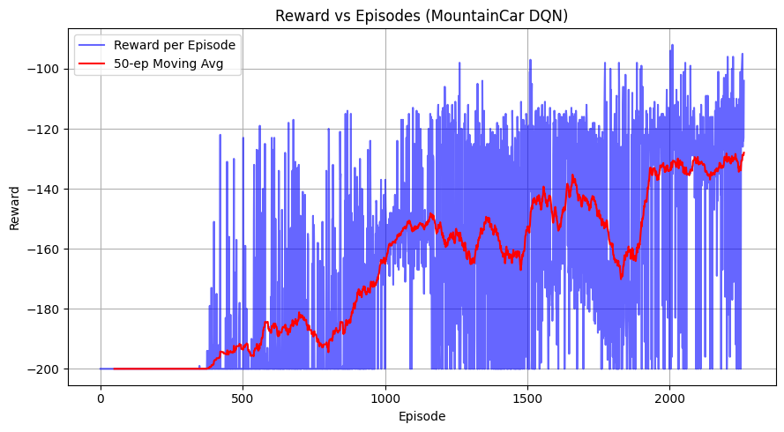
Also let’s test the agent whether it is able to reach the goal or not.
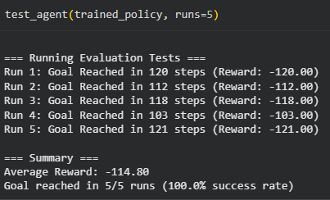

Now let’s us see the Roulette problem solved using the DQN:
class RouletteEnv(gym.Env):
metadata = {"render_modes": []}

def __init__(self, spins_per_episode=10):
super().__init__()
self.action_space = spaces.Discrete(3)
self.observation_space = spaces.Discrete(1)
self.state = np.array([0.0])
self.spins_per_episode = spins_per_episode
self.current_spin = 0

def spin(self):
number = np.random.randint(0, 37)
if number == 0:
return 2 # green
elif 1 <= number <= 18:
return 0 # red
else:
return 1 # black

def step(self, action):
outcome = self.spin()
if action == outcome:
reward = 35.0 if action == 2 else 1.0
else:
reward = -1.0

# Reward normalization
reward = reward / 10.0 # scale down large wins
self.current_spin += 1
done = self.current_spin >= self.spins_per_episode

return self.state, reward, done, False, {}

def reset(self, seed=None, options=None):
super().reset(seed=seed)
self.state = np.array([0.0])
self.current_spin = 0
return self.state, {}

class QNetwork(nn.Module):
def __init__(self, state_size, action_size, hidden_size=64):
super(QNetwork, self).__init__()
self.model = nn.Sequential(
nn.Linear(state_size, hidden_size),
nn.ReLU(),
nn.Linear(hidden_size, hidden_size),
nn.ReLU(),
nn.Linear(hidden_size, action_size)
)

def forward(self, x):
return self.model(x)

class ReplayBuffer:
def __init__(self, capacity=10000):
self.buffer = deque(maxlen=capacity)

def push(self, state, action, reward, next_state, done):
self.buffer.append((state, action, reward, next_state, done))

def sample(self, batch_size):
batch = random.sample(self.buffer, batch_size)
states, actions, rewards, next_states, dones = zip(*batch)
return (
torch.FloatTensor(states),
torch.LongTensor(actions),
torch.FloatTensor(rewards),
torch.FloatTensor(next_states),
torch.FloatTensor(dones)
)

def __len__(self):
return len(self.buffer)

def train_dqn(env, episodes=5000, batch_size=64, gamma=0.95, lr=5e-3):
state_size = 1
action_size = env.action_space.n

policy_net = QNetwork(state_size, action_size)
target_net = QNetwork(state_size, action_size)
target_net.load_state_dict(policy_net.state_dict())
optimizer = optim.Adam(policy_net.parameters(), lr=lr)
buffer = ReplayBuffer()

epsilon = 1.0
epsilon_decay = 0.997
epsilon_min = 0.05
update_target_every = 100

all_rewards = []

for episode in range(1, episodes + 1):
state, _ = env.reset()
done = False
total_reward = 0

while not done:

if random.random() < epsilon:
action = env.action_space.sample()
else:
with torch.no_grad():
q_values = policy_net(torch.FloatTensor(state))
action = torch.argmax(q_values).item()

next_state, reward, done, _, _ = env.step(action)
buffer.push(state, action, reward, next_state, done)
state = next_state
total_reward += reward

if len(buffer) >= batch_size:
states, actions, rewards, next_states, dones = buffer.sample(batch_size)
q_values = policy_net(states).gather(1, actions.unsqueeze(1)).squeeze(1)
with torch.no_grad():
next_q_values = target_net(next_states).max(1)[0]
target = rewards + gamma * next_q_values * (1 - dones)
loss = nn.MSELoss()(q_values, target)

optimizer.zero_grad()
loss.backward()
optimizer.step()

all_rewards.append(total_reward)
epsilon = max(epsilon * epsilon_decay, epsilon_min)

if episode % update_target_every == 0:
target_net.load_state_dict(policy_net.state_dict())

if episode % 1000== 0:
avg_reward = np.mean(all_rewards[-1000:])
print(f"Episode {episode}/{episodes} | Avg Reward (last 1000): {avg_reward:.2f} | Epsilon: {epsilon:.2f}")

return policy_net

def test_agent(policy_net, env, runs=10):
print("\n=== Running Evaluation Tests ===")
total_rewards = []
success_count = 0

for i in range(runs):
state, _ = env.reset()
done = False
total_reward = 0

while not done:
with torch.no_grad():
q_values = policy_net(torch.FloatTensor(state))
action = torch.argmax(q_values).item()
next_state, reward, done, _, _ = env.step(action)
total_reward += reward

total_rewards.append(total_reward)
if total_reward >= 0:
success_count += 1
print(f"Run {i+1}: Total Reward = {total_reward:.2f} Goal Reached")
else:
print(f"Run {i+1}: Total Reward = {total_reward:.2f} Goal Not Reached")

avg_reward = np.mean(total_rewards)
print("\n=== Summary ===")
print(f"Average Reward: {avg_reward:.2f}")
print(f"Goal reached in {success_count}/{runs} runs ({(success_count/runs)*100:.1f}% success rate)")

The test was performed on the Roulette agent and below is the result of the goal reached:
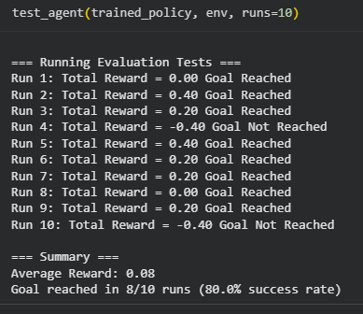

The third and final problem is the shortest path problem achieved using the RL(Q-Learning) and DQN by constructing the graph from scratch.
class GraphEnv:
def __init__(self, n_nodes, edges, start, goal, max_steps=50):
self.n = n_nodes
self.adj = {i: [] for i in range(n_nodes)}
for u, v, w in edges:
self.adj[u].append((v, w))
self.start = start
self.goal = goal
self.max_steps = max_steps
self.reset()

def reset(self):
self.state = self.start
self.steps = 0
return self.state

def step(self, action):
neighbors = self.adj[self.state]
next_node, w = neighbors[action]
self.steps += 1
done = False
if next_node == self.goal:
reward = 100.0 - w
done = True
else:
reward = -w
if self.steps >= self.max_steps:
done = True
self.state = next_node
return self.state, reward, done, {}

def valid_actions(self, state=None):
if state is None:
state = self.state
return list(range(len(self.adj[state])))

def train_q_learning(env, episodes=2000, alpha=0.5, gamma=0.99, eps_start=1.0, eps_end=0.05):
Q = {s: np.zeros(len(env.adj[s])) for s in range(env.n)}
eps_decay = (eps_start - eps_end) / episodes
eps = eps_start
start_time = time.time()
for ep in range(episodes):
s = env.reset()
done = False
while not done:
valid = env.valid_actions(s)
if random.random() < eps:
a = random.choice(valid)
else:
a = int(np.argmax(Q[s]))
next_s, r, done, _ = env.step(a)
if not done and len(env.adj[next_s]) > 0:
Q_next_max = np.max(Q[next_s])
else:
Q_next_max = 0.0
Q[s][a] += alpha * (r + gamma * Q_next_max - Q[s][a])
s = next_s
eps = max(eps - eps_decay, eps_end)
train_time = time.time() - start_time
return Q, train_time

def evaluate_q(env, Q):
s = env.reset()
path = [s]
done = False
while not done and len(path) < env.max_steps:
a = int(np.argmax(Q[s]))
s, r, done, _ = env.step(a)
path.append(s)
if done:
break
return path

class DQN(nn.Module):
def __init__(self, state_dim, action_dim):
super().__init__()
self.net = nn.Sequential(
nn.Linear(state_dim, 64), nn.ReLU(),
nn.Linear(64, 64), nn.ReLU(),
nn.Linear(64, action_dim)
)

def forward(self, x):
return self.net(x)

class ReplayBuffer:
def __init__(self, capacity=10000):
self.buffer = deque(maxlen=capacity)

def push(self, state, action, reward, next_state, done):
self.buffer.append((state, action, reward, next_state, done))

def sample(self, batch_size):
batch = random.sample(self.buffer, min(len(self.buffer), batch_size))
s, a, r, s2, d = zip(*batch)
return np.array(s), a, r, np.array(s2), d

def __len__(self):
return len(self.buffer)
def train_dqn(env, episodes=2000, gamma=0.99, eps_start=1.0, eps_end=0.05, lr=1e-3, batch_size=64, target_update=50, early_stop_patience=100):
device = torch.device('cuda' if torch.cuda.is_available() else 'cpu')
state_dim = env.n
action_dim = max(len(env.adj[s]) for s in range(env.n))

policy_net = DQN(state_dim, action_dim).to(device)
target_net = DQN(state_dim, action_dim).to(device)
target_net.load_state_dict(policy_net.state_dict())

optimizer = optim.Adam(policy_net.parameters(), lr=lr)
buffer = ReplayBuffer(10000)

eps = eps_start
eps_decay = (eps_start - eps_end) / episodes
start_time = time.time()

best_reward = -float('inf')
no_improve_count = 0

for ep in range(episodes):
s = env.reset()
s_vec = np.zeros(env.n)
s_vec[s] = 1.0
done = False
total_reward = 0

while not done:
valid = env.valid_actions(s)
if random.random() < eps:
a = random.choice(valid)
else:
with torch.no_grad():
q_values = policy_net(torch.FloatTensor(s_vec).to(device))
mask = torch.full((action_dim,), -1e9, device=device)
mask[valid] = q_values[valid]
a = int(torch.argmax(mask).item())

next_s, r, done, _ = env.step(a)
total_reward += r
ns_vec = np.zeros(env.n)
ns_vec[next_s] = 1.0

buffer.push(s_vec, a, r, ns_vec, done)
s, s_vec = next_s, ns_vec

if len(buffer) >= batch_size:
s_b, a_b, r_b, s2_b, d_b = buffer.sample(batch_size)
s_b = torch.FloatTensor(s_b).to(device)
s2_b = torch.FloatTensor(s2_b).to(device)
a_b = torch.LongTensor(a_b).to(device)
r_b = torch.FloatTensor(r_b).to(device)
d_b = torch.FloatTensor(d_b).to(device)

q_values = policy_net(s_b).gather(1, a_b.unsqueeze(1)).squeeze()
with torch.no_grad():
q_next = target_net(s2_b).max(1)[0]
target = r_b + gamma * q_next * (1 - d_b)

loss = nn.MSELoss()(q_values, target)
optimizer.zero_grad()
loss.backward()
optimizer.step()

eps = max(eps - eps_decay, eps_end)

if total_reward > best_reward:
best_reward = total_reward
no_improve_count = 0
else:
no_improve_count += 1

if no_improve_count >= early_stop_patience:
print(f"Early stopping at episode {ep} with best reward {best_reward:.2f}")
break

if (ep + 1) % target_update == 0:
target_net.load_state_dict(policy_net.state_dict())

train_time = time.time() - start_time
return policy_net, train_time
def evaluate_dqn(env, net):
device = torch.device('cuda' if torch.cuda.is_available() else 'cpu')
s = env.reset()
path = [s]
done = False
action_dim = max(len(env.adj[s]) for s in range(env.n))
while not done and len(path) < env.max_steps:
s_vec = np.zeros(env.n)
s_vec[s] = 1.0
with torch.no_grad():
q_values = net(torch.FloatTensor(s_vec).to(device))
mask = torch.full((action_dim,), -1e9, device=device)
mask[env.valid_actions(s)] = q_values[env.valid_actions(s)]
a = int(torch.argmax(mask).item())
s, _, done, _ = env.step(a)
path.append(s)
return path
def floyd_warshall_table(edges, n_nodes):
INF = float('inf')
dist = np.full((n_nodes, n_nodes), INF)
np.fill_diagonal(dist, 0)
for u, v, w in edges:
dist[u][v] = w
dist[v][u] = w
for k in range(n_nodes):
for i in range(n_nodes):
for j in range(n_nodes):
if dist[i][j] > dist[i][k] + dist[k][j]:
dist[i][j] = dist[i][k] + dist[k][j]
df = pd.DataFrame(dist, columns=[f'Node {i}' for i in range(n_nodes)])
df.index = [f'Node {i}' for i in range(n_nodes)]
return df
edges = [
(0, 1, 1.0), (0, 2, 2.0),
(1, 3, 2.0), (2, 3, 1.0),
(1, 4, 5.0), (3, 4, 1.0),
(4, 5, 1.0), (2, 5, 5.0)
]

G = nx.Graph()
G.add_weighted_edges_from(edges)
pos = nx.spring_layout(G)
nx.draw(G, pos, with_labels=True, node_color='skyblue', node_size=1500, font_size=10)
edge_labels = nx.get_edge_attributes(G, 'weight')
nx.draw_networkx_edge_labels(G, pos, edge_labels=edge_labels, font_color='red')
plt.show()

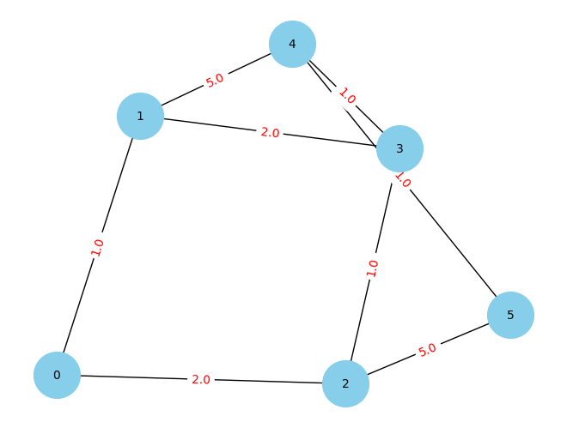
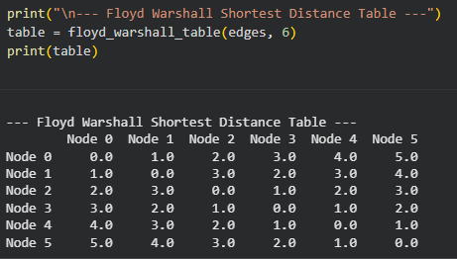
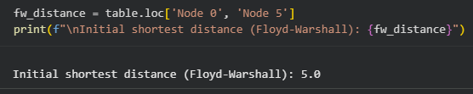

The shortest distance problem needs to be solved using both the Q-Learning and DQN and needed to log into the table for comparison. First we calculate the all pair shortest path using the Floyd-Warshall algorithm for reporting the true distance of shortest path available.
Then, we are going to calculate the shortest path using Q-Learning and DQN and also log the shortest distance registered and also the path taken to achieve the shortest distance. Below is the comparison:
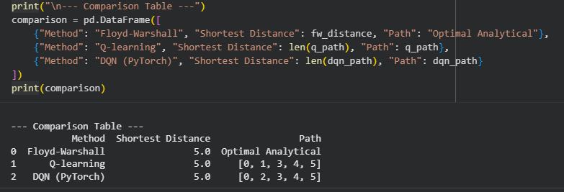

From here we can observe that the true distance of shortest path between node-0 and node-5 is 5. Q-Learning and DQN both performed great here as they both registered shortest distance 5 and though the path taken by them are different but by observing the graph we can conclude that both the path taken truly leads to the target using the shortest path.

Conclusion:
The Q-Learning creates a Q-table that stores the reward gained for each course of state and action. The agent performs action and thus is assigned reward/penalty based upon it. The Mountain Car problem tries to teach the agent to climb uphill to reach the goal. Upon multiple iteration and reward/penalty allotment the agent finally was able to climb the mountain. The test performed has a 100% success rate of achieving the goal. Below is the image attached:

The Roulette problem is also a very random problem in RL where the agent takes bets on a range of numbers available and targets to take its current balance to target balance. The Q-table is also created upon the (bet number, bet amount). Upon multiple iterations the agent finally learns to take bets to take the current balance amount to the target balance amount. This achievement is shown below:

The DQN is another approach to RL where the neural network replaces the traditionally used Q-table to approximate the (state, action) → reward. This pulls down the hassle to discretize the values for action as needed in the Q-Learning. The neural network learns to model to be able to approximate the inputs. The mountain car problem is being able to learn and perform greatly. Below is the performance test:

The roulette problem is also trained using DQN and below is the performance:

The shortest path problem in graph is one of the classical problems and below is the graph:
The final table obtained is:

Github Link: Link

